**WEEK-2**

**Exercise 1: Mocking and Stubbing**

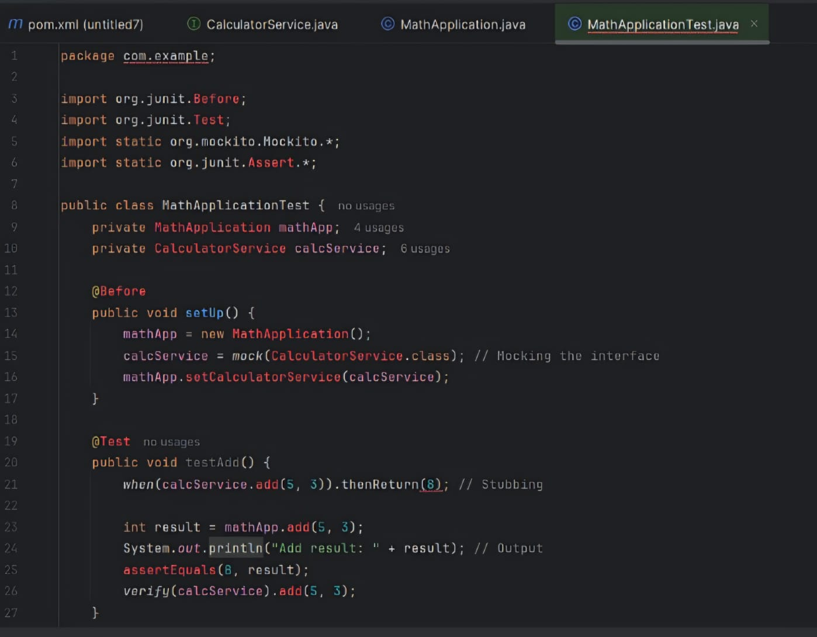

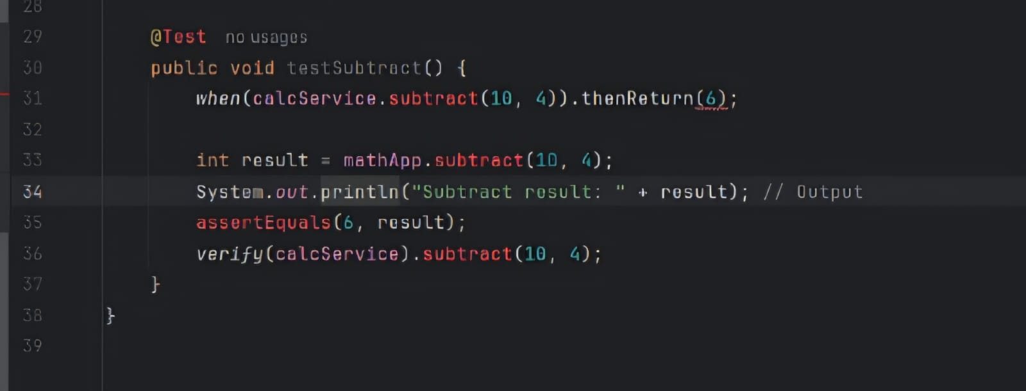

OUTPUT:

